**Purpose:** To use if statements in a program to change variables and produce a quadrilateral on the screen.

**Description**: You will create a window on the screen that is no smaller than 800 x 600 and no larger than 1024 x 768. Your program is designed to remember four (x,y) coordinate points on the screen. These points are set one at a time when the mouse button is clicked. Each time a point is set, draw a small white circle at that coordinate (20 x 20). Once all four points have been established, your program will then draw a quadrilateral based on those points. Override the mouseClicked() method so that it will store where mouseX and mouseY are located in the correct variables. Here are some steps to help:

1) Identify what type of variables (containers) you need to store 4 points as well as remember how many mouse clicks have happened. Put these variables at the top of your program.

2) Use the proper control structure(s) in the draw() method so that the small circles are only drawn after the appropriate mouse click and the quad() method is called after 4 mouse clicks have happened.

3) When writing the mouseClicked() method, make sure you are updating the appropriate variables – not only remembering where the mouse was at the time of the click, but how many clicks have happened so far in the program.

Here are some screen shots after each mouse click:

**After 1 mouse click**:

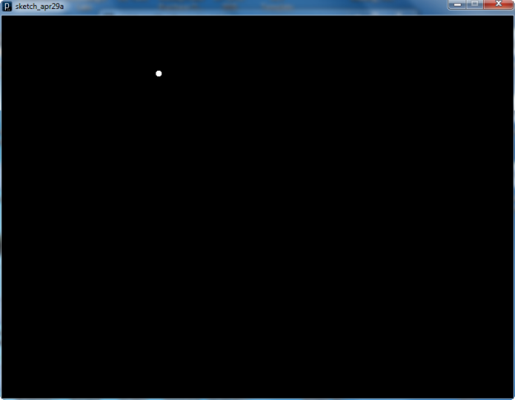

**After 2 mouse clicks** :

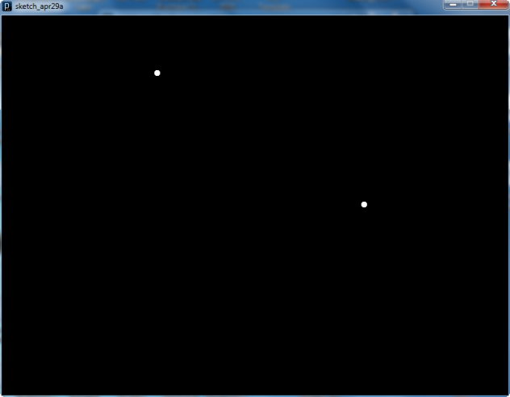

**(More pictures below)**

**After 3 mouse clicks** :

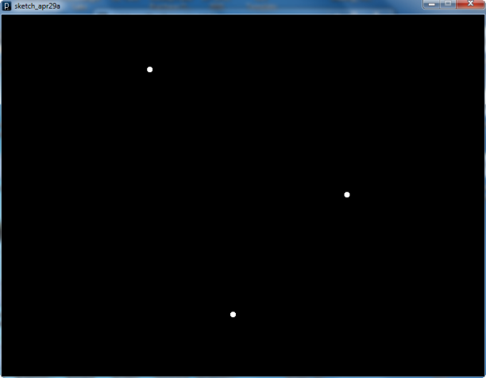

**After 4 mouse clicks** :

